steveweeksmusic.com

Purpose
- to market my CDs and music performances
- to present a professional, experienced image
- to provide a platform on which to learn more about Flash development and graphic design
- To provide a fun safe place for kids to visit

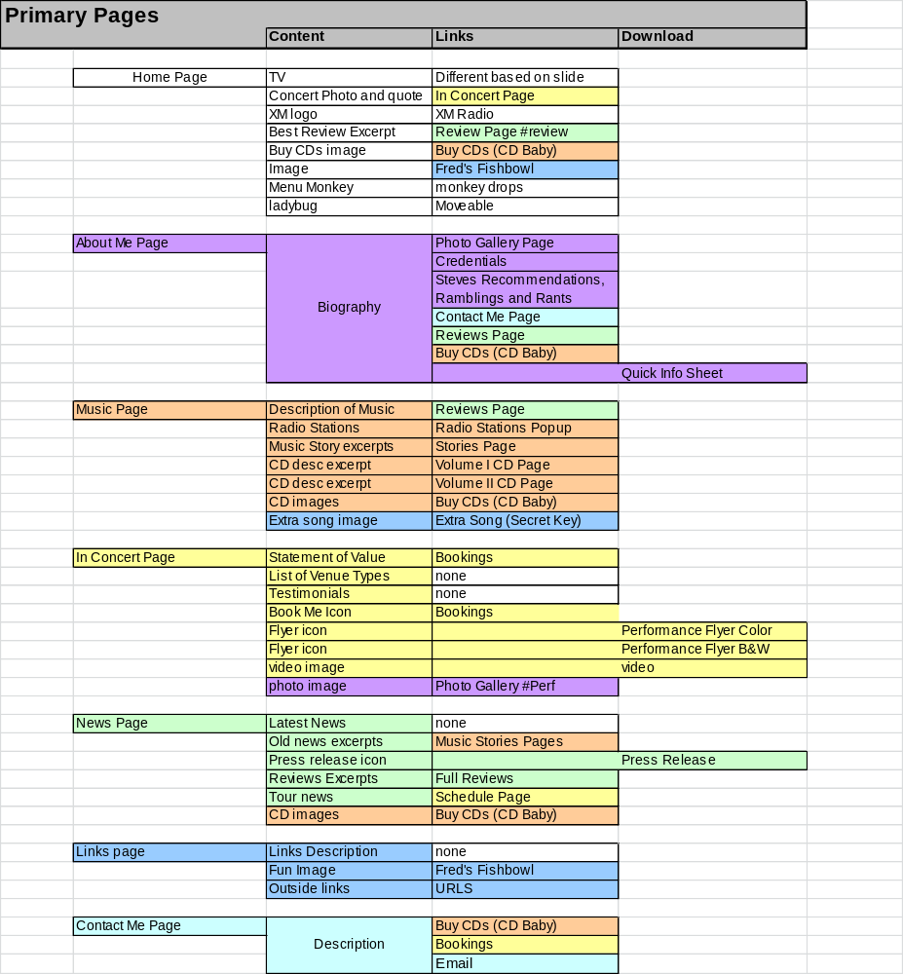

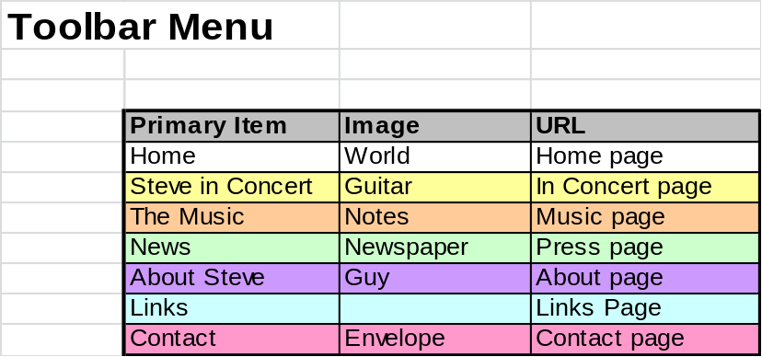

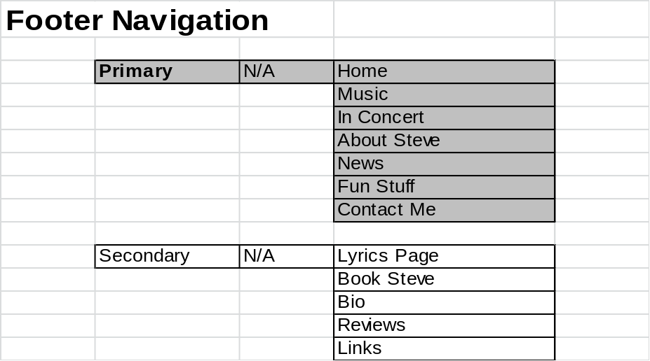

Look and Feel
- animated
- fun
- colorful
- sense of clutter but actually clean
- interactive
- cartoon

Animated and Interactive Elements on Home Page

Flash Player Detection
Fun photo of Steve with simple easy-to-understand message and 2 choices
- Go to non-flash version
- Get Flash Player 8

Loading image
Globe Spinning with a percentage loaded. Says “Steve Weeks Music” on it somewhere.
Link to abandon loading and go to non-flash version

Movie
The page starts as a blank white screen (humming and footsteps echo). A door opens (door opening) and a man walks in (humming and footsteps without echo). He starts walking across the screen. A pull cord drops (slide whistle down). He stops and looks at the cord. (Hmmm) He looks up. He pulls the cord (click). Suddenly a cartoon chest falls from the sky and lands in front of him. (falling noise and crunch). He walks to the chest and opens it (footsteps and creak). He begins throwing things out of it (random clamor). All of the elements on the screen are thrown out of the chest to their positions. He looks up at the layout (mmm hmmm). He walks back to the rope and pulls it (click). The Text on the page flickers and lights up (neon buzzing). The rope quickly raises (slide whistle up). He looks up and then looks forward frightened (falling sound again). He runs off the screen just in time for a TV to fall where he would have been (bigger crunch). The TV flickers static and then says “Steve TV”. The door closes and disappears (door shutting) The screen is now ready.

Menu Monkey
Occasionally a monkey drops from a vine or appears from behind the menu bar and points to an item. I balloon appears so that the monkey describes the general area and encourages the use to go there. If clicked, the monkey falls off the page, and the vine retracts.

Lady Bug
A ladybug constantly crawls across the screen. It’s moveable

Television
A cartoon TV constantly flickers and then shows some item of interest for a while. When menu items are moused-over, the TV flickers and show a description of that general area.
An XML file will control the slides displayed. Each record will indicate the name of the image, any text to be displayed, and the URL if the slide is selected.
- Logo with intro message
- Photos of performances with performance quotes (3)
- Best CD quotes (3)
- Latest News (e.g. contests)
- Awards Slides (NAPA, Parent’s Choice, ISC)
- Radio slides (XM radio, Spare the Rock, WERS)
- Encouragement to visit deep parts of the site

Things to learn in Flash
- How to sync sound with animation
- How to incorporate video
- Slideshow
- How to incorporate HTML within a little movie (news)
- Flash player detection page

Images Needed
- Fun Image
- Steve Weeks Music Logo
- Flash Detection Steve

Sounds Needed
- Humming
- Footsteps (wait to see animation)
- Falling
- Small crunch
- Big Crunch
- Hmmmm
- Mmmm Hmmm
- Cord pull click
- Neon buzz
- TV Buzz
- clamor

Things to do for Home Page

- Finish Intro basics
- Add “Go to non-flash” and www.steveweeksmsusic.com to Loading
- Change fonts on Monkey and TV
- Design Homepage
- Fred’s Fishbowl Image
- URLs for all homepage items
- TV
Steve Weeks Music Logo
TV Logo
- Retro-fit Homepage to Intro
- Motion paths for all elements
- Flickering words
- Make all items bounce when TV hits
- How to get last item in place
- Sound
- Finishing Details
- Fine tune Colors and timing of all elements
- Populate Slides XML file
- Adjust Monkey cords array
- rename and document stuff
- Figure out anchor
- Other pages
- Create Menu SWF (resize)
- Create non-flash Home page
- Create non-flash Fred Fishbowl
- Create Flash detection page

Music Page

In Concert Page

News Page

About Steve Page

Links Page

Contact Page

Vol. I Page

Vol. II Page

Music Stories Page

Book Me Page
Similar to current page

Schedule Page
Controlled by XML (read in through PHP).
Header at top allows you to go to specific month/year
Most current show is promoted at top

Reviews Page

Photos Page

Credentials Page

Ramblings Page

Lyrics Page

Fred’s Fishbowl Page

Don’t Press Button
A button that warns the user not to press. If selected, the page falls apart?

If I Were A…
User is prompted to submit a “C” word. If found the verse and credentials are posted. User can submit if not found.

Monkey Game
Game based on menu monkey.

Secret Song
Enter key code and get song.

Puzzle Pages
PDF files of puzzles and coloring pages

Kids Links
Links to cool kid-safe websites (non-music)

Kiki’s Kangaroo Trivia Test
Javascript page of kangaroo trivia

